QA Documentation-Akshaya Testing
Story:
USER STORY 1136042
Description:
File maintenance>Customer Maintenance>Pricing Master>(select a account)>(select Exceptions)>Price Exceptions

We need to be able to call the delete/archive function for the Price Exception Items from multiple applications and it perform the same function regardless of the application it was called from.

Modify the delete/archive procedure for the Price Exceptions items to be a stored procedure that can be called from multiple applications, the logic of the delete/archive should not be changed.

The stored procedure will be used by the Price Exception AshleyNet page, the weekly Auto Remove Dead Items job and any future application that needs to delete/archive a Price Exception item.
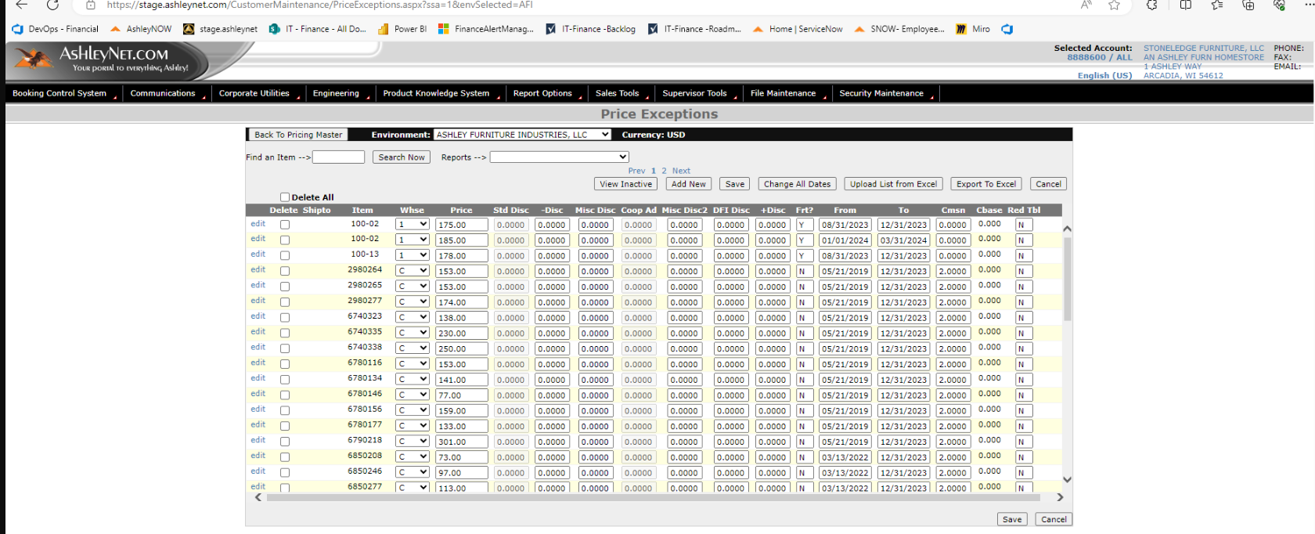

Acceptance Criteria

The Price Exception Item delete/archive should work as it currently does and be able to be called from multiple applications.

Comments of Lynn
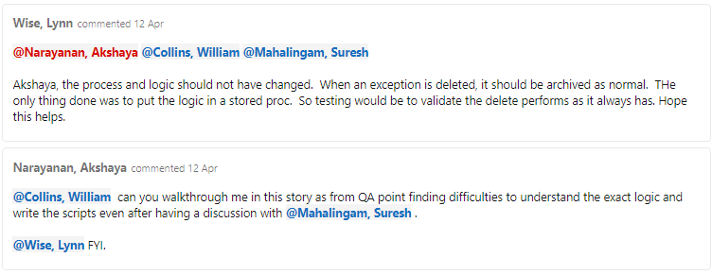

Testing Screenshots:

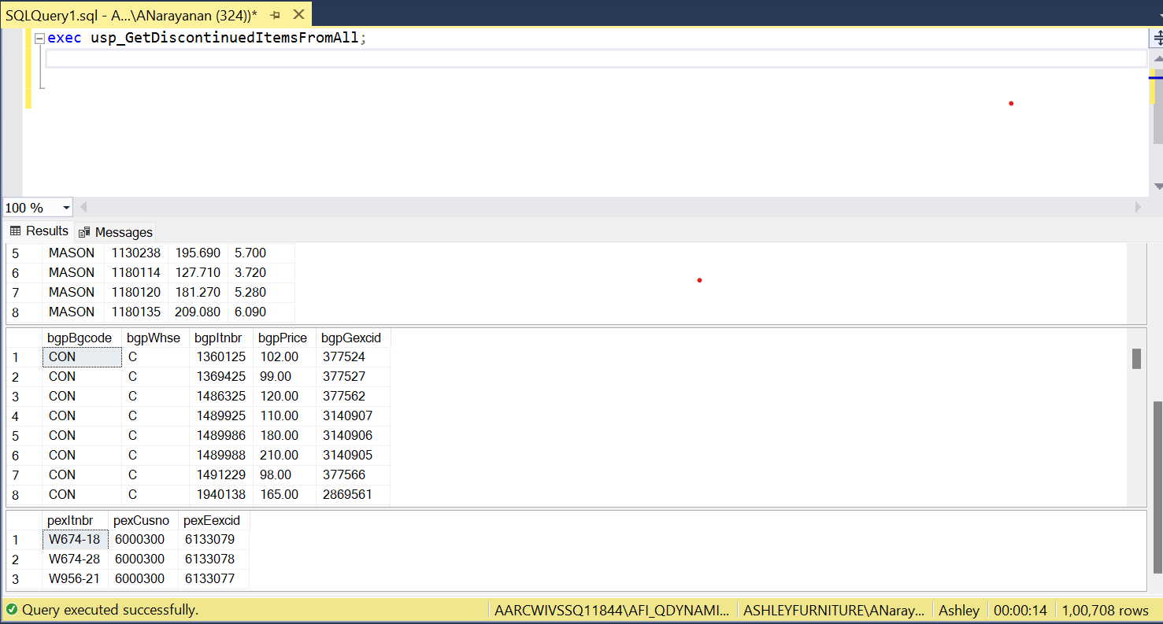
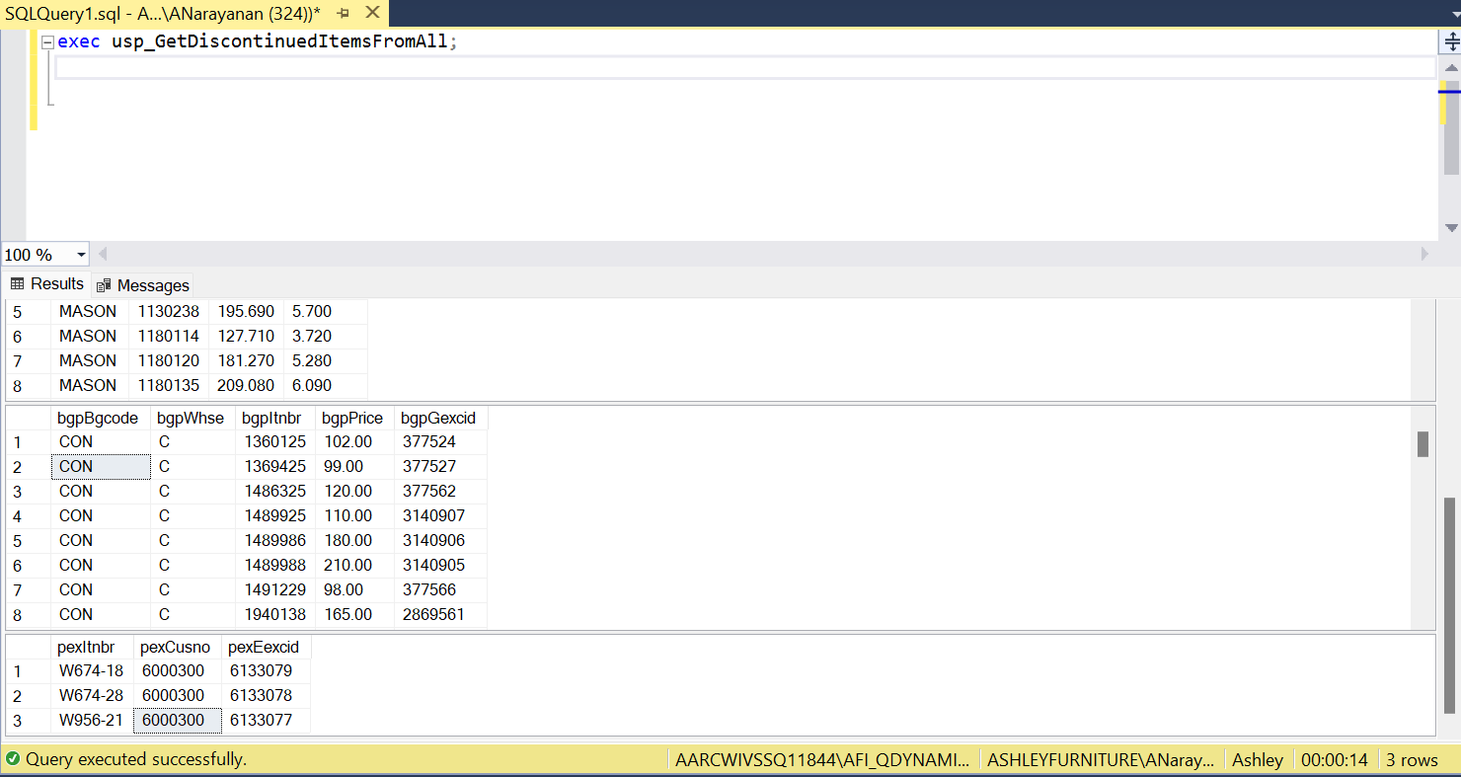

#buyer
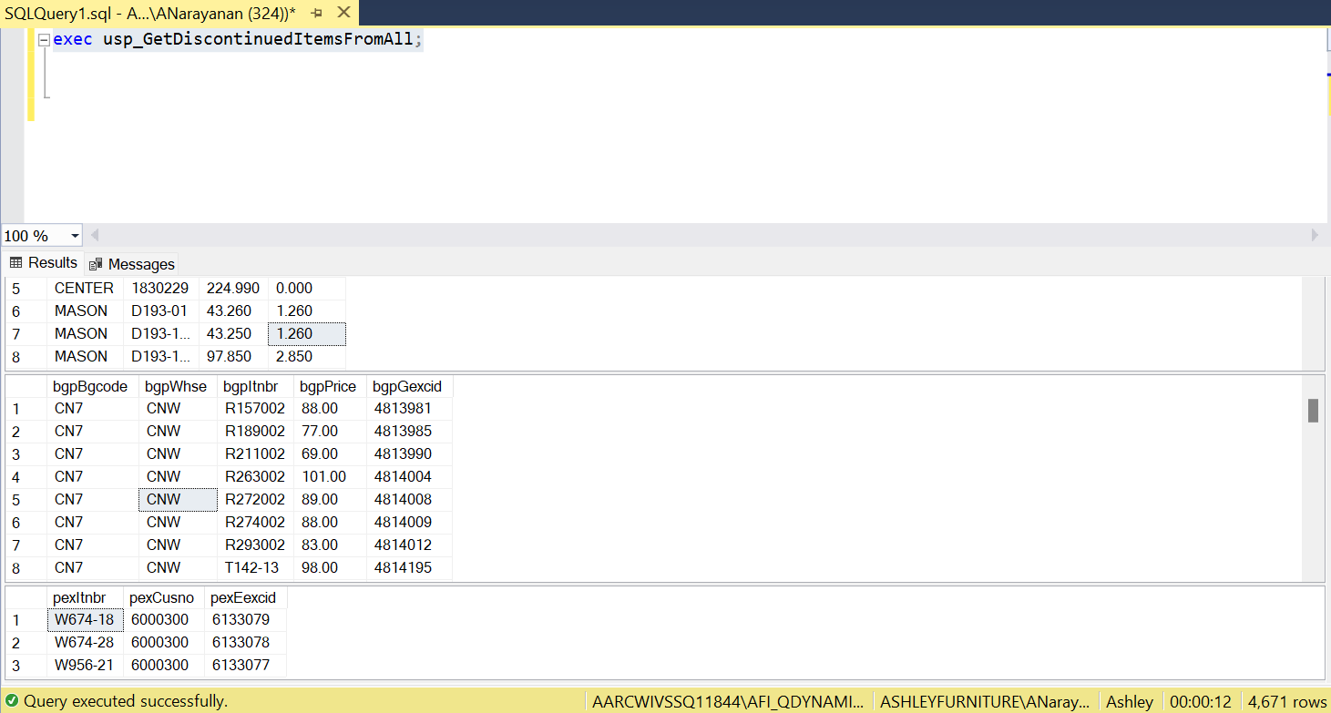
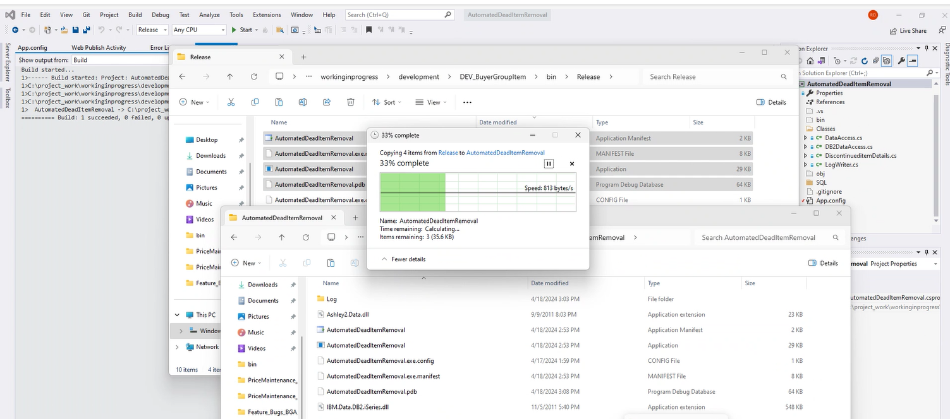
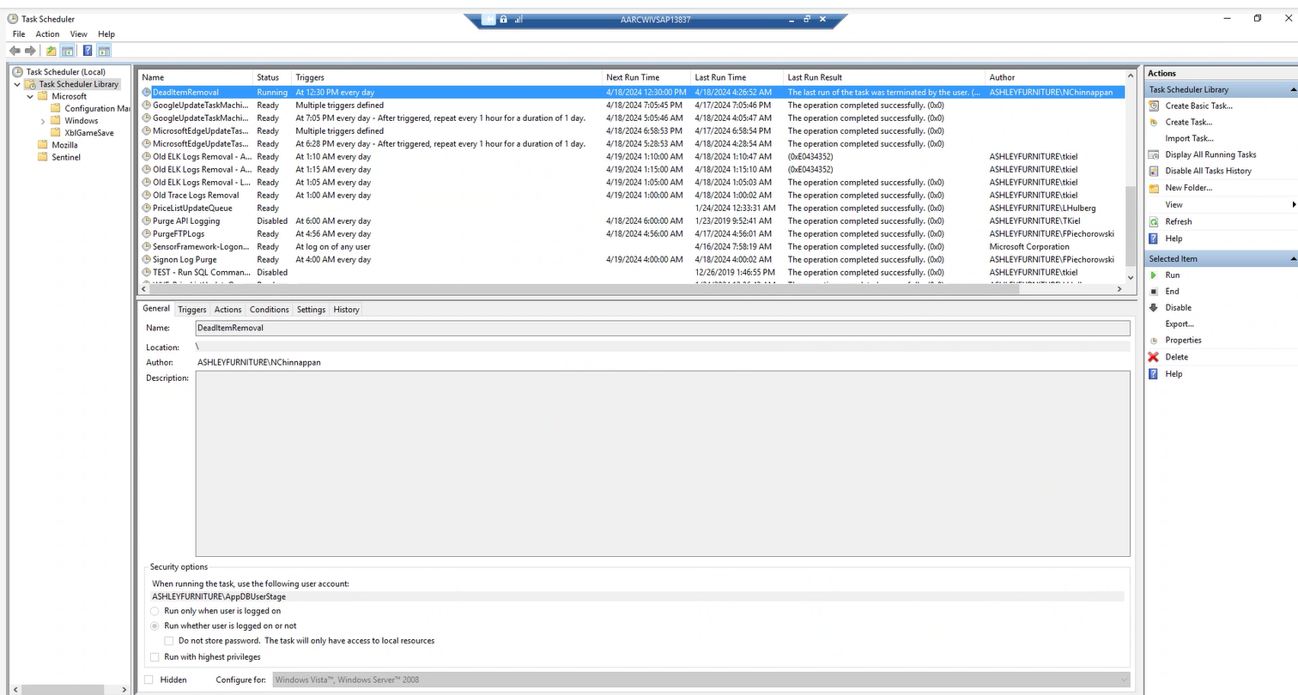
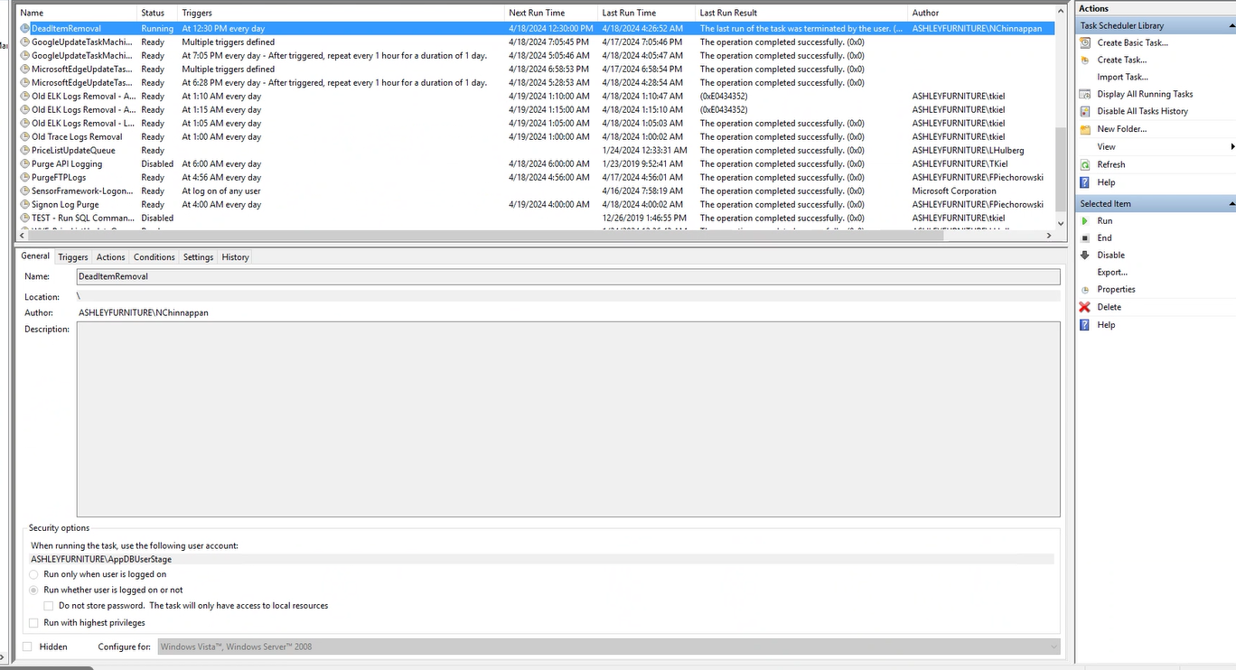
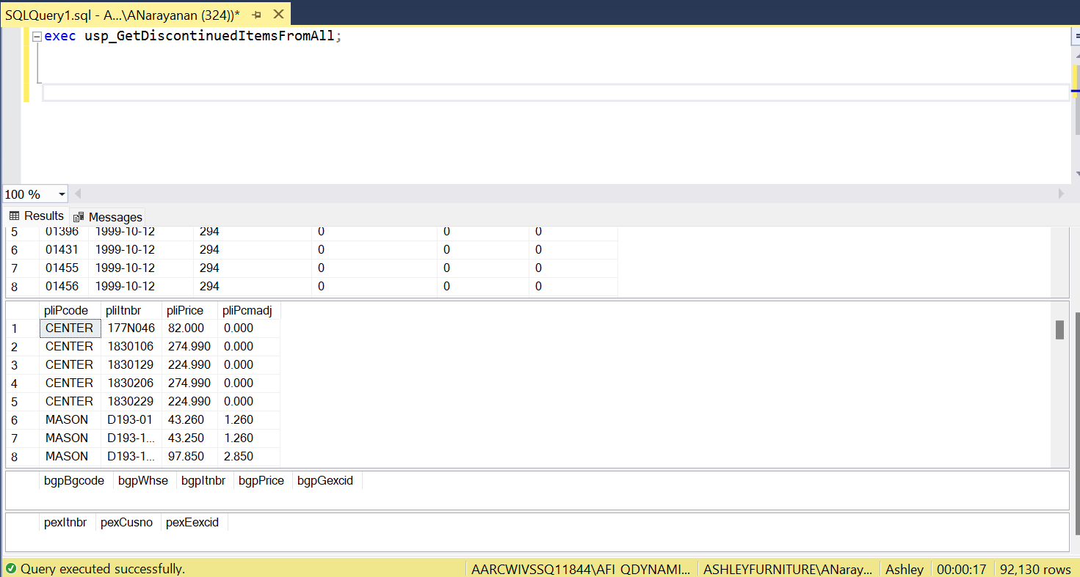
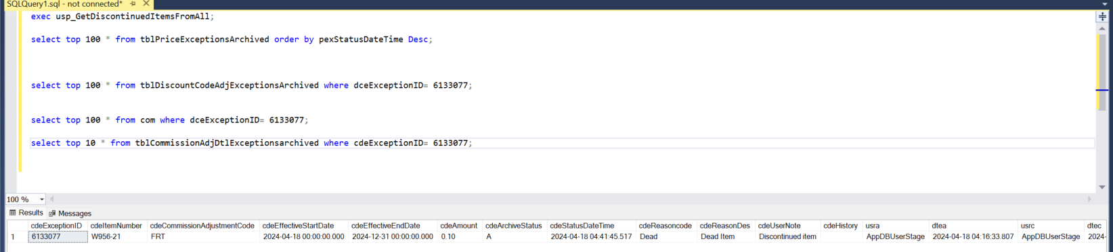
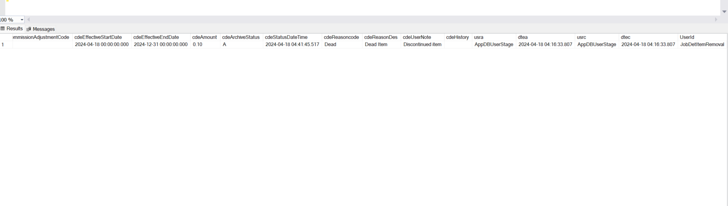

Used Queries
[Wednesday 15:11] Mahalingam, Suresh
- exec usp_GetDiscontinuedItemsFromAll
- select top 100 * from tblDiscountCodeAdjExceptionsArchived where dceExceptionID=
- select top 10 * from tblCommissionAdjDtlExceptionsarchived where cdeExceptionID=
Result:
PASS

